**Dokumentasi Project DATABASE ROOM**

1. Membuat project baru

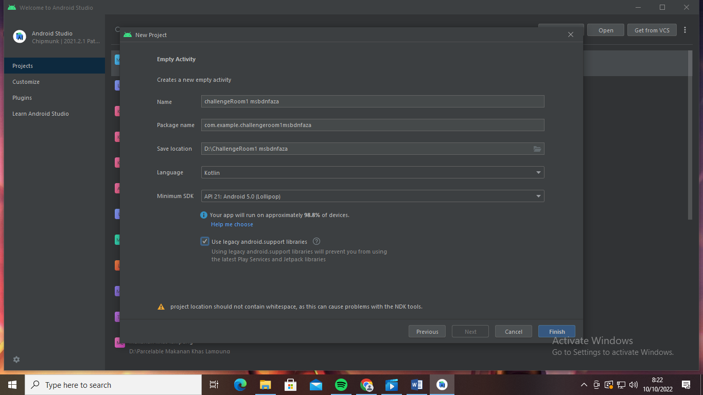

1. Edit gradle

//material design  
def material_version = "1.2.1"  
implementation "com.google.android.material:material:$material_version"  
  
//Room  
def room_version = "2.2.5"  
implementation "androidx.room:room-runtime:$room_version"  
kapt "androidx.room:room-compiler:$room_version"  
  
//Coroutines  
def coroutines_version = "1.3.9"  
implementation "androidx.room:room-ktx:$room_version"  
implementation "org.jetbrains.kotlinx:kotlinx-coroutines-core:$coroutines_version”

-plugin

id'com.android.application'  
id 'org.jetbrains.kotlin.android'  
id 'kotlin-kapt'

1. Membuat tabel data siswa

Pilih app -> java-> klik kanan-> kotlin class/file -> file

Diberi nama “tbsiswa” -> pilih class

* Masukan source code
* @Entity  
  data class tbsiswa (  
   @PrimaryKey(autoGenerate = true)  
   val nis:Int,  
   val nama:String,  
   val kelas:String,  
   val alamat:String

1. Membuat Dao

* Pilih app -> java -> klik kanan -> new -> kotlin class/file ->

Diberi nama “SiswaDao” -> pilih interface

Lalu masukkan source code

@Dao  
interface SiswaDao {  
 @Insert  
 fun addNote (note: tbsiswa)  
  
 @Update  
 fun updateNote (note: tbsiswa)  
  
 @Delete  
 fun deleteNote (note: tbsiswa)  
  
 @Query("SELECT * FROM tbsiswa")  
fun getNote(note: tbsiswa) :List<tbsiswa>

1. Membuat Database dbsmksa

* Pilih app -> java -> klik kanan -> new kotlin class/file ->

Diberi nama “dbsmksa” -> pilih class

Lalu masukkan source code

@Database(  
entities = [tbsiswa::class],  
version = 1  
)  
abstract class dbsmksa : RoomDatabase(){  
  
 abstract fun noteDao() : SiswaDao  
  
 companion object {  
  
 @Volatile private var instance : dbsmksa? = null  
 private val LOCK = Any()  
  
 operator fun invoke(context: Context) = instance ?: *synchronized*(LOCK)**{** instance ?: buildDatabase(context).*also* **{** instance = **it  
 }  
 }** private fun buildDatabase(context: Context) = Room.databaseBuilder(  
 context.*applicationContext*,  
 dbsmksa::class.*java*,  
 "note12345.db"  
 ).build()